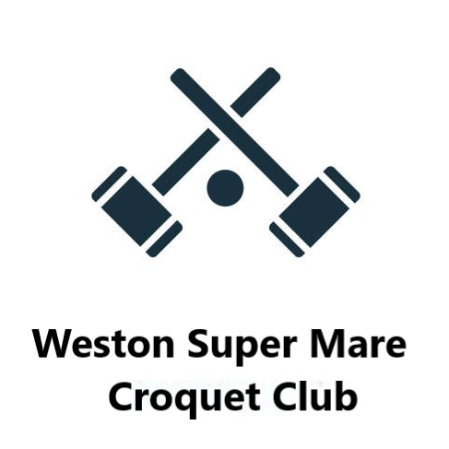

**Newsletter – April 2024**

With huge thanks to our lawns and groundworks team of James, Graham, Brian, Mike, Jan, and Glenys, we were able to open the lawns on 9th April. They braved cold, wet, and windy weather to size the lawns, set the hoops and a super job by Glenys with impeccable white lining. On a lovely sunny but very gusty afternoon, the first hoop was run by James and a roll-up followed.

The first Saturday Pairs competition run by Mike Dudley through the season, started on the 13th of April. It is held on Saturday mornings and starts at 9.45. This year we will be playing to the Advantage system of handicaps.

The SWF AC Short Croquet Tournament was held at Nailsea on 12th April. Our team captained by Jan did very well coming second. Everyone played well, particular congratulations to Jon Knowler who won all his games.

The All-England Golf Handicap 2024 has been announced. Last year we were delighted that Terry Allen got through to the final. The competition is open to anyone whose handicap is 8 or lower.

The games will be played to the Advantage system of handicaps to align with Croquet England policy. The area final for SWF will be at Bath on August 11th.

The grand final will be 14-15th September at Guildford and Godalming Croquet Club. All those who wish to enter our Club heats please register your interest with Pauline on 07870 352744.

An old friend and member, Eileen Ainsley, has moved to Ireland to be near family. She has kindly donated her mallet to the Club which has been taken into our stock of mallets. Also donated: a mallet cover, a white polo shirt with Club logo (size 14), a white shower proof jacket size 14, for anyone who would like them for a small donation to the Club. We wish Eileen every happiness in her new home.

Dates for your diary:

The first Golf League match will be between Weston Golf League team “A” (Captain Jan) and Weston Golf League team “B” (Captain Lance) on Wednesday, 8th May.

The first AC B league (Captain Jan) match will be home to Bath on Sunday, 9th June.

The Red, Whites and Blues Competition is scheduled for Tuesday 21st May.

We will be holding an open day on Sunday 19th May which coincides with Croquet England open week.

A reminder from the Committee that subs of £200 are due by the end of April to maintain your membership. Bank details are Weston- super-Mare Croquet Club, Lloyds Bank, Sort code 30-98-97, Ac No 59837162 for electronic transfers or by cheque to the Treasurer, Jan Scotchmer.

Best Wishes to all our members for a fine, successful, season.

Pauline McAllister

Secretary

07870 352744